SmartCare v0.3 - Domain Model Workbook
Week 6 student resource

Requirement-to-Concept Trace
Requirement | Concept | State/behaviour | Decision
Functional | Every patient should be stored with a corresponding ID/MRD. | Necessary for patient search in project code. | Accept
Functional | Practitioners should also have a unique identifier (ID) to help patients determine who to consult through web searches. | Necessary for practitioner search in project code. | Accept
Functional | The appointment booking system should perform validation checks to identify booking gaps, cancellations, and scheduling conflicts. | Should specify what will happen when it does check in software code. | Accept
Functional | The system should record data dictionaries of all important medical, GP and booking information for appointment histories. | May need to include different data storage types depending on how the program is. | Modified/Accepted
Functional | The system sends prior notification to practitioners, receptionists, and patients when it shuts down for updates/errors, and it will only do so during non-working hours. | Specify ‘non-working hours’ in the system. | Accepted
Functional | The practitioner will send input to the receptionist with a specific field called item number that will give them the go-ahead to process patient payments. | What code features will be used to make this? | Accepted
Functional | The practitioner can choose the input type for the patient's payment between bulk billing (full cost of services is sent to Medicare to pay (Medicare must be enroll/applied for by an Australian citizen for any consultation)) and direct private payment (A more expensive payment paid by the patient; still includes payment from Medicare but less than bulk bill). | What code features will be used to make this? | Accepted
Functional | The receptionist will check whether the system has received both the item number field sent from the practitioner and the input type from them in relation to the patient payment method. | What code features will be used to make this? | Accepted
Functional | When the patient comes to the receptionist to check in after the appointment, the system will either request them to make a direct private payment or inform them of the successful bulk billing. | How will this information be sent to the receptionist through the system? | Accepted
Functional | After making a direct private payment, the system will send the patient a financial receipt to confirm the payment method. | Through email or as a PDF, what format will it be? | Accepted

CRC Cards

Patient
Responsibilities | Collaborators
Patient ID | Practitioner
Patient MRN | Receptionist
Patient First Name/Last Name | Medical Record
Private/Viewable Medical Record
Book Consultation Session
View Practitioner Information

Practitioner
Responsibilities | Collaborators
Practitioner ID | Patient
Process Payment Items | Receptionist
Practitioner First Name/Last Name | Medical Notes
Viewable Patient Medical Record | Practice Manager
View Scheduled Bookings
Patient diagnosis

Appointment
Responsibilities | Collaborators
Patient/Practtioner ID/or MRN | Patient
Book Consultation Session | Practitioner
Practitioner First Name/Last Name | BestPractice System
Patient First Name/Last Name | Practice Manager
View Scheduled Bookings

Payment
Responsibilities | Collaborators
Processed Payment Items | Receptionist
Item Number | Practioner
Bulk Billing/Direct Private Payment Options | Medical Provider
System message to receptionist | Bank Details

UML Class Diagram
Insert/draw UML here. Include defensible relationships and multiplicities.
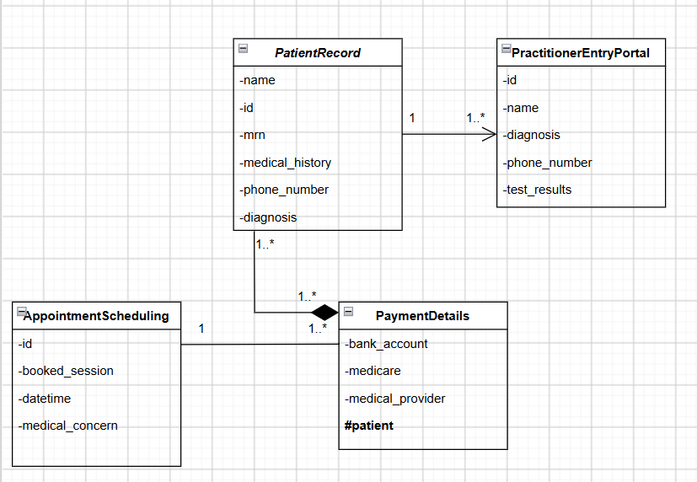

Design Rationale
Explain class selection, responsibility allocation and key relationships.
The various class types decided on were string, int, the use of datetime, MySQL and the interface itself for the various class groups of patients, practitioners, appointments, and payment. The responsibility allocation for the CRC cards covered the various stores of information and things the specified class could achieve, like the ID/MRN storage or viewable medical records. The key relationships defined in the UML class diagram, on the other hand, include the following relationships with each other: direct association, composition and association. Defining class objects helps to specify the relationships between them and how they might interact with the physical software code in the future.

AI Design Review Record
AI suggestion | Evidence | Decision | Reason | Model change
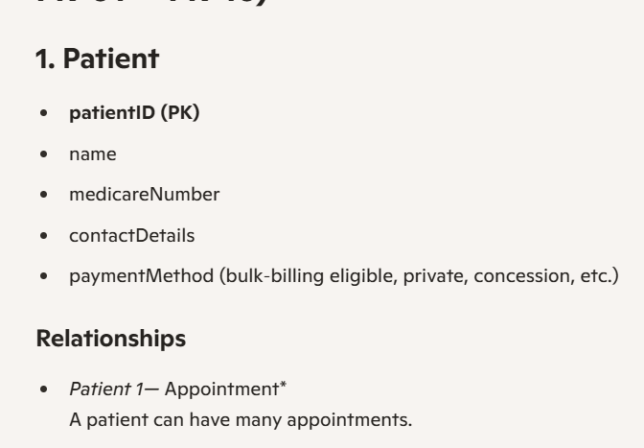  Figure 1 Copilot AI Prompt | Based on the system BestPractices, they leave the payment method entirely up to the practitioners' decision-making. | Rejected/Modified | The paymentMethod class should not be there, as the paymentMethod is not derived from the patient but the practitioner. | Changing it to reflect the patient's medical background and/or diagnosis would be a good consideration.
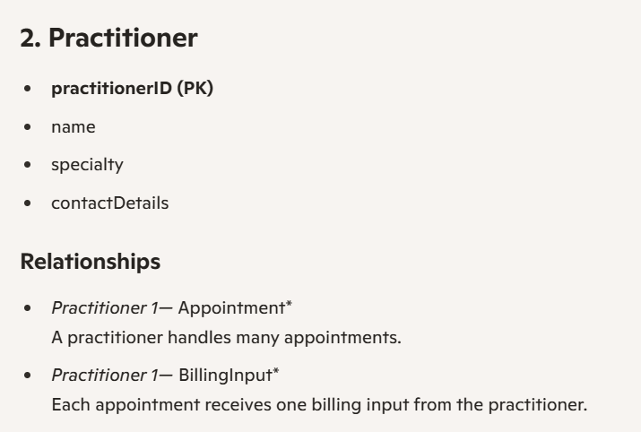  Figure 2 Copilot AI Prompt | Every practitioner has their own specialty, whether that is a dentist or a GP, etc. | Accepted | Including the addition of the practitioner’s specialty was a good consideration. Relationships are well defined. | More on the features they have access to would be informative.
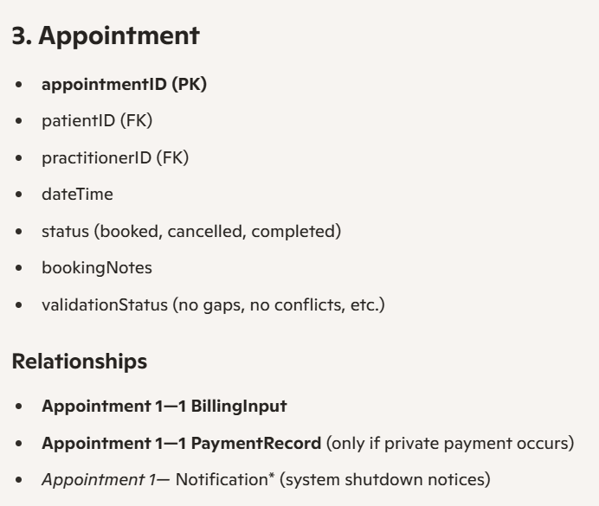  Figure 3 Copilot AI Prompt | The BestPractice System would have to have the datetime and/or status/booking notes. | Accepted | The change from medical concern to booking notes is better, as it allows more flexibility from the patient's perspective. | There is nothing to change.
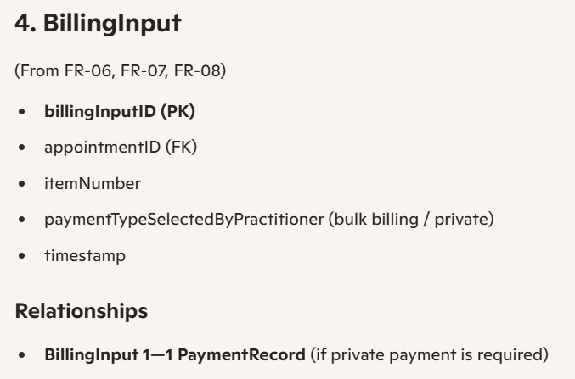  Figure 4 Copilot AI Prompt | According to the analysis on the BestPractice System, there are two billing types, meaning there should be a portal for this function. | Accepted | BillingInput has all the necessary classes like ItemNumber and paymentTypeSelectedByPractitioner. | There is nothing to change.
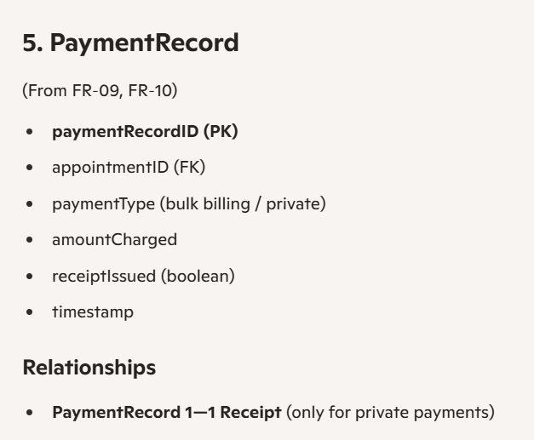  Figure 5 Copilot AI Prompt | The functional requirements specified the need for a receipt. | Accepted/Modified | Is good, but it is not necessary to have paymentType. | Should get rid of paymentType and instead focus on the other classes and how they work.

